EXPERIMENT 12 Phone num e database management

A]ALGORITHM
Step 1: Start
Step 2: Read integer n (number of commands)
Step 3: Create an empty dictionary ph
Step 4: Repeat steps for i = 1 to n
- Read command input and split into list cmd
- If cmd[0] == "ADD"
  - Add contact → ph[name] = number
- Else if cmd[0] == "REMOVE"
  - Remove contact using pop()
- Else if cmd[0] == "DISPLAY"
  - If dictionary is empty → Print "No contacts"
  - Else → Sort dictionary keys and print name:number
Step 5: Stop
B] code
n=int(input())
ph={}
for i in range(n):
CMD = input().split()
if CMD[0]=="ADD":
ph[CMD[1]]=CMD[2]
elif CMD[0]=="REMOVE":
ph.pop(CMD[1],None)
elif CMD[0]=="DISPLAY":
if len(ph)==0:
print("No contacts")
else:
for name in sorted(ph):
print(f"{name}: {ph[name]}")

C]FLOWCHART
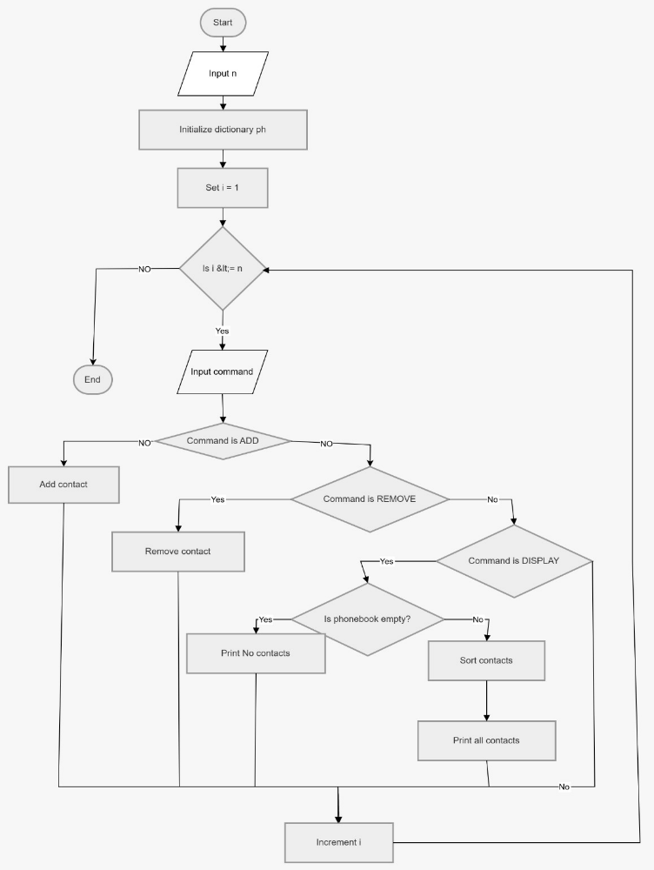

D]CODETANTRA
